Section 1: Case Summary

Scenario Title: | Pediatric Submersion
Keywords: | PALS, Cardiac arrest, Drowning, Submersion
Brief Description of Case: | A three-year-old child was swimming with their family, when they wandered into the deep end and submerged under water. The parents noticed the child was below the surface. When the child was brought to the surface, they were unconscious and coughing up foam. EHS arrived, provided oxygen supplementation, and brought them to your tertiary emergency department, with access to PICU.  In the ED, the child is unconscious with increasing respiratory distress, requiring intubation. Despite intubation, the child remains hypoxemic and the team works through an approach to post-intubation hypoxemia. Unfortunately, the child becomes bradycardic. The team should begin CPR and follow the PALS pediatric bradycardia algorithm. PICU should be called if not already involved. After one round of CPR, the patient’s heart rate will increase and the consulting team should arrive.

Goals and Objectives
Educational Goal: | Solidify an approach to post-intubation hypoxemia and the principles of the PALS algorithm.
Objectives:  (Medical and CRM) | 1. Apply crisis resource management principles including closed-loop communication and assigning roles to effectively lead the team through the care of a critically ill pediatric patient.  2. Use a shared mental model to communicate with team members management priorities.  3. Effectively communicate patient condition when speaking with appropriate consulting specialists.  4. Consider a broad differential in your approach to hypoxemia.  5. Identify management differences in respect to a critically ill pediatric patient.
EPAs Assessed: | Core EPA: C1 Resuscitating and coordinating care for critically ill patients.

Learners, Setting and Personnel
Target Learners: | ☐ Junior Learners |  | ☒ Senior Learners |  |  | ☐ Staff
 | ☒ Physicians | ☒ Nurses |  | ☒ RTs | ☒ Inter-professional
 | ☐ Other Learners:
Location: | ☒ Sim Lab |  | ☐ In Situ |  |  | ☐ Other:
Recommended Number of Facilitators: | Instructors: 2
 | Sim Actors: Optional 1
 | Sim Techs: 1

Scenario Development
Date of Development: | Oct 25, 2022
Scenario Developer(s): | Dr. Katie Maguire, Content Expert: Dr. Nikki Holm
Affiliations/Institutions(s): | UBC
Contact E-mail: | k.maguire@alumni.ubc.ca
Last Revision Date: | Oct 26, 2022
Revised By:
Version Number:

Section 2A: Initial Patient Information

- Patient Chart
Patient Name: Lyla |  |  |  | Age: 3 years | Gender: F | Weight: 16 kg
Presenting complaint: Respiratory distress
Temp: 34.0 | HR: 150 | BP: 85/40 |  | RR: 40 | O₂Sat: 90% assisted breaths | FiO₂: 100%
Cap glucose: 5.0 mmol/L |  |  |  | GCS: 8 (E1V2M5)
Triage note:

3-year-old female previously healthy presents post-submersion in a backyard pool with respiratory distress.
Allergies: NKDA
Past Medical History:  Born healthy at 38 weeks SVD |  |  | Current Medications:  none

Section 2B: Extra Patient Information

A. Further History
Include any relevant history not included in triage note above. What information will only be given to learners if they ask? Who will provide this information (mannequin’s voice, sim actors, SP, etc.)?

A three-year-old child was swimming with their family, when they wandered into the deep end and submerged under water. The parents noticed the child was below the surface and brought them to the surface. They are unsure exactly how long the submersion was. There is no concern for trauma or axial load injuries.

The child was unconscious but breathing spontaneously. She was coughing up a white frothy substance periodically. The mom brought the unconscious child to the pool deck, while the dad called the paramedics. It took < 15 minutes for EHS to arrive. When EHS arrived, the child had a pulse of 100 bpm and was spontaneously breathing. Despite 100% Fi02, her Sp02 remained 90%. She was brought to the nearest ED where you are the physician to assess her.
B. Physical Exam
List any pertinent positive and negative findings
Airway: Frothy foam in the airway, coughing, protecting airway | Circulation: cool, clammy, cap refill < 2 secs, distal and central pulses palpable
Cardio: S1/S2, no murmurs | Neuro: eyes closed, groaning to pain, localizing, poor tone
Resp: Noisy chest, bilateral crackles, and wheeze | Head & Neck: unremarkable, no c-spine collar
Abdo: mildly distended, soft, non-tender | MSK/skin: no bruising, no signs of trauma
Other: looks stated age

Section 3: Technical Requirements/Room Vision

A. Patient
☒ Mannequin (infant/child)
☐ Standardized Patient
☐ Task Trainer
☐ Hybrid
B. Special Equipment Required
Defibrillator and pads
EKG leads/wires
NIBP Cuff
Pulse oximeter
Esophageal temperature probe
Intubation supplies (Pediatric airway cart preferred)
Capnography
Bair Hugger
IV Bags/Lines
PALS algorithm
C. Required Medications
PALS medication
D. Moulage
Damp gown
Airway foam (frothy white/pink sputum)
E. Monitors at Case Onset
☒ Patient on monitor with vitals displayed
☐ Patient not yet on monitor
F. Patient Reactions and Exam
Include any relevant physical exam findings that require mannequin programming or cues from patient
(e.g. – abnormal breath sounds, moaning when RUQ palpated, etc.) May be helpful to frame in ABCDE format.

A – Frothy foam in the airway, not obstructing airflow but visualization during intubation, coughing, protecting airway
B – increased work of breathing, crackles and diffuse wheeze
C – cool, clammy, cap refill 2 secs, distal and central pulses palpable
D – PERLA, GCS 8 (E1V2M5), no focality, no weakness
E – full log roll does not show signs of trauma, no bleeding, no bruising

Section 4: Sim Actor and Standardized Patients

Sim Actor and Standardized Patient Roles and Scripts
Role | Description of role, expected behavior, and key moments to intervene/prompt learners. Include any script required (including conveying patient information if patient is unable)
Not applicable

Section 5: Scenario Progression

Scenario States, Modifiers and Triggers
Patient State/Vitals | Patient Status | Learner Actions, Modifiers & Triggers to Move to Next State |  | Facilitator Notes
1. Baseline State  Rhythm: Sinus  HR: 150  BP: 85/40  RR: 38  O₂SAT: 90% with BVM, assisted respiration  T: 34ºC  GCS: E1V2M5 | The patient is obtunded (GCS 8), with increased work of breathing, coughing up foam, wheezes throughout, cool to touch | Expected Learner Actions  IV access, apply monitors, full set of vitals (glucose), bring in pediatric crash cart  Obtain a core temp (rectal)  Warming measures (Bair hugger, warm IV fluids)  Hi flow O2 or BiPAP  Initial blood work, chest Xray  Call for help (PICU/ECMO)  Consider inhaled bronchodilators  Set ambient room temperature higher for warming | Modifiers  Changes to patient condition based on learner action  - Positive pressure improves hypoxemia (from 90 to 93%).  - Bronchodilators improve bronchospasm  Triggers  For progression to next state  - Decision to intubate | If not moving to intubate, continue to have respiratory status deteriorate
2. Definitive airway  Rhythm: Sinus  HR: 150 bpm  BP: 85/40  RR: 38  O₂SAT: 94% with BVM  T: 36ºC  GCS: E1V2M5 | Optimize and intubate | Expected Learner Actions  Ensure good seal and 100% Fi02 for pre-oxygenation (max Sp02 94%)  Recognize difficult airway (airway foam)  Communicate an airway plan  Weight based equipment and RSI medications  Confirm intubation with EtC02 and chest xray  Post-intubation sedation | Modifiers  - If inadequate pre-oxygenation Sp02 will fall rapidly to 88% on first attempt  - Regardless of pre-oxygenation have Sp02 fall to 80% post-intubation  Triggers  - Once intubated proceed to next stage | Persistent suctioning is not helpful, and creates more foam. PPV improves airway view.  RT to prompt for post intubation settings (lung-protective) and ABG.  Weight-based airway equipment/meds  - Cuffed 4.5 ETT  - 2 straight/curved  - 15 cm ETT depth  - Ketamine 1.5 mg/kg IV  - Roc 1.2 mg/kg IV
3. Post intubation Hypoxemia  Rhythm: Sinus  HR: 150 bpm  BP: 85/40  RR: 25 vented  O₂SAT: 80% post-intubation, improvement to 85%  T: 36ºC  GCS: Sedated | Post intubation the patient’s 02 saturations fall. | Expected Learner Actions  Confirm 100% Fi02  Confirm ETT placement (EtC02, visual inspection)  Suction ETT, assess for tube obstruction  Assess for Pneumothorax and bronchospasm (US/CXR/listening)  Take patient off the ventilator and use bag/valve  Modify vent settings (increase PEEP, consider stacking)  Deepen sedation, give paralytic if not already given  Repeat gas, CXR  Place NG/OG to decompress the stomach | Modifiers  - Give team CXR if ordered  - Copious secretions come through the ETT, Sp02 improve to 87%  - If team manually bags the patient, note it is difficult to bag  - bronchodilator administration, increasing PEEP and deepening sedation all improve saturations  - if manual BVM, saturations improve to 90%  Triggers  - Move to next stage if removed the patient from the ventilator and apply BVM or 5 minutes have elapsed.
4. Bradycardia with poor perfusion  Rhythm: Sinus  HR: 50 bpm  BP: 85/40  RR: RR 25 vented  O₂SAT: 88% on 100% Fi02  T: 36ºC  GCS: Sedated | Despite the team’s best efforts to troubleshoot the post-intubation hypoxemia, the patient’s heart rate falls to below 60.  Child is intubated, sedated, and has signs of poor perfusion | Expected Learner Actions  Recognize pediatric bradycardia as an emergency  Start CPR given HR < 60 bpm  Give PALS Epi (0.01 mg/kg IV)  Give PALS atropine dose (0.02 mg/kg)  Call for help (PICU, code ECMO | Modifiers  - Team may continue trouble shooting the post-intubation hypoxemia  Triggers  - At first pulse check, HR increases to 100 bpm and the case ends. | Team should recognize hypoxia as the most likely cause of bradycardia. They can consider a broad differential including hypothermia (recheck temp), meds (sedating infusions), glucose

Appendix A: Laboratory Results

CBC
WBC 10
Hgb 125
Plt 325

Lytes
Na 135
K 4.8
Cl 100
HCO₃ 12
AG 18
Urea 4
Cr 40
Glucose 5.0

VBG
pH 7.20
pCO₂ 20
pO₂ 60
HCO₃ 12
Lactate 5

Appendix B: ECGs, X-rays, Ultrasounds and Pictures

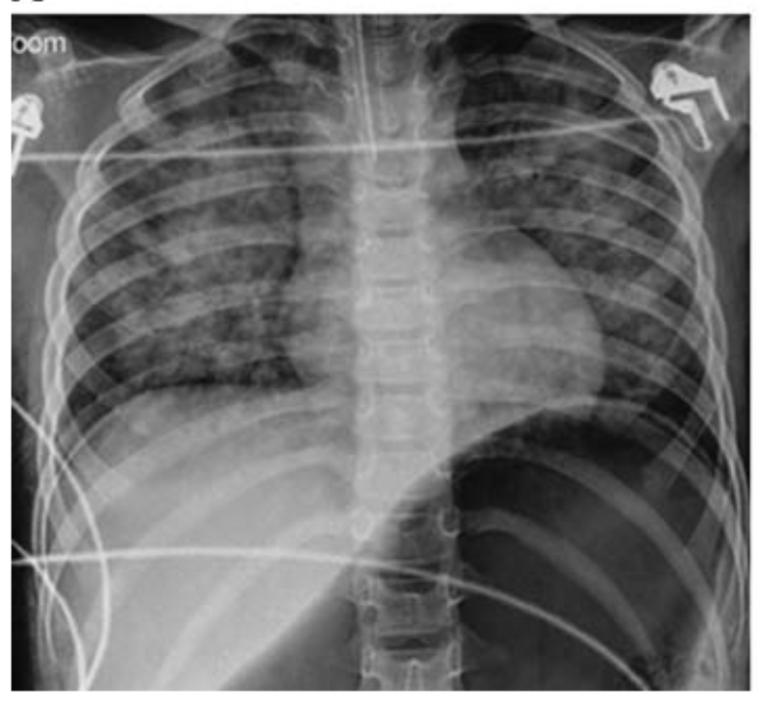
Hon, K. , So, K. , Wong, W. , Cheung, H. & Cheung, K. (2016). Radiologic, Neurologic and Cardiopulmonary Aspects of Submersion Injury. Pediatric Emergency Care, 32 (9), 623-626. doi: 10.1097/PEC.0000000000000477.
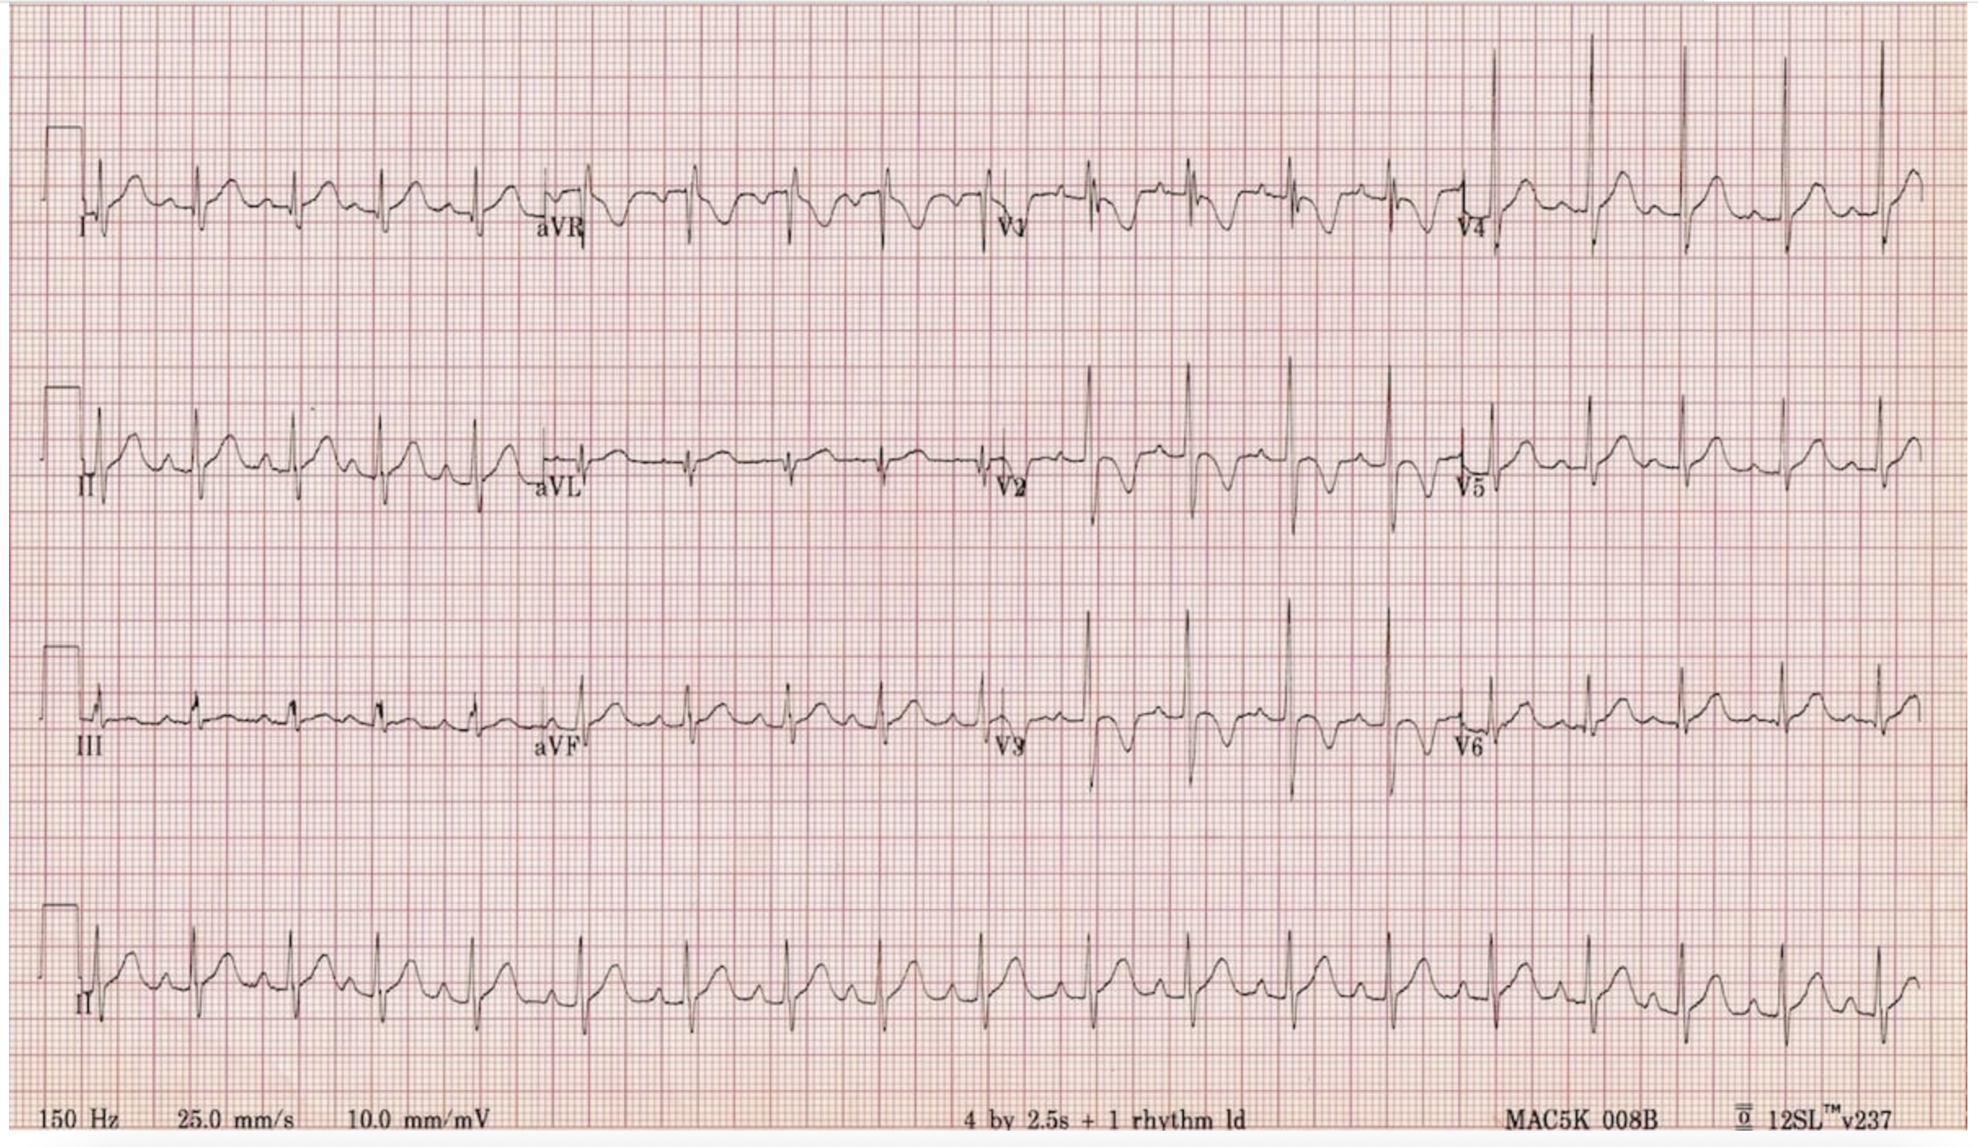
https://litfl.com/normal-paediatric-ecg/

Appendix C: Facilitator Cheat Sheet & Debriefing Tips

Include key errors to watch for and common challenges with the case. List issues expected to be part of the debriefing discussion. Supplemental information regarding any relevant pathophysiology, guidelines, or management information that may be reviewed during debriefing should be provided for facilitators to have as a reference.

Crisis-resource management questions:

- When pediatric patients do not respond as we expect or continue to get sicker, it can be stressful. How did the resuscitation team manage this challenge? What tools did you use today (or have used in real life) that can help mitigate the stress of seeing a deteriorating child.
  - Hints: summarizing, sharing your mental model, calling for help early, apps, algorithms such as PALS. (The pediatric bradycardia algorithm is attached in Appendix 1).

- Was your whole team aware of the differences in management for pediatric bradycardia? Do you feel that the differences in priorities were communicated? Was it challenging to initiate chest compressions in a child with a pulse?

Medical management questions (see cheat sheet below)

- Drowning cases are rare but scary. It can be hard to conceptualize the differences in physiology in a drowning patient while a sick patient is in front of you. What were you worried about given this was a drowning patient?
  - Follow up question: Given this pathophysiology, are there specific ventilator settings that make sense for this patient?

- I noticed this patient became hypoxemic post-intubation and I saw the group takes steps to mitigate that hypoxemia through x, y and z. If we were stop and gather the team’s thoughts, what might that have looked like? Does anyone have an approach to post-intubation hypoxemia they feel comfortable sharing.
  - Further questioning: is ECLS a consideration in this patient for refractory hypoxia? (The BC Children’s ECLS guideline is attached as Appendix 2).

Cheat Sheet for Medical Management questions:
Drowning cases are rare but scary. It can be hard to conceptualize the differences in physiology in a drowning patient while a sick patient is in front of you. What were you worried about given this was a drowning patient?

Drowning is the process of respiratory impairment from immersion or submersion in a liquid. Drowning occurs when our airway is submerged or immersed in liquid and reflex inspiratory efforts occurs. When water enters the airway, bronchospasm and surfactant disruption ensues. Surfactant washout results in atelectasis, and water causes direct cellular injury causing further pulmonary edema. Surfactant washout can occur with even a small amount of water (just 3 – 4 cc/kg of water) and lead to decreased lung compliance, V/Q mismatch and intrapulmonary shunting.

Laryngospasm occurs when the liquid encounters our lower airways and our vocal cords reflexively close. Laryngospasm obstructs our airway protecting our lungs from water. Unfortunately, forceful breathing against a closed glottis can cause negative pressure pulmonary edema and lead to further hypoxemia.

“Surfactant foam” is a mixing of alveoli surfactant with small volumes of water. This foam is low density and does not produce physical obstruction. Rather than suctioning, you should ventilate through the foam. These pathways lead to progressive hypoxia resulting in neurologic ischemia and cardiovascular collapse.

a. Follow up question: Given this pathophysiology, are there specific ventilator settings that make sense for this patient?

The Wilderness Medical Society (WMS) recommends using a lung protective ventilation strategy similar to those with ARDS, on the premise that the lung injury pattern is similar. Specifically, the tidal volume (Vt) should be 6 – 8 cc/kg. Initial Fi02 set to 100%, then titrated to Pa02 55 to 80 mm Hg. The Vt and RR should be adjusted to maintain plateau pressure <30 mm Hg.

I noticed this patient became hypoxemic post-intubation and I saw the group takes steps to mitigate that hypoxemia through x, y and z. If we were stop and gather the team’s thoughts, what might that have looked like? Does anyone have an approach to post-intubation hypoxia they feel comfortable sharing.

  - Further questioning: is ECLS a consideration in this patient for refractory hypoxia? (The BC Children’s ECLS guideline is attached below for reference)

After taking a moment to discuss the utility of sharing your mental model, a brief review of an approach to post-intubation hypoxemia may be helpful.

“DOTTSS” is a mnemonic that is commonly taught.
- Disconnect the patient from the ventilator, eliminate equipment failure
- Oxygen: Apply 100% Fi02 through a bag valve mask
- Tube: check tube position with VL, suction the tube to ensure there is no obstruction or kinks.
- Tweak the vent: optimize ventilator settings, consider the pathophysiology. Will this patient benefit from more PEEP? Is there an eliminate of Autopeep that may require prolonged exhalation?
- Sonography: assess for pneumothorax
- Squeeze: if you have concerns about auto-PEEP, ensure you disconnect the patient and give them a “bear hug” exhalation.
- Lastly Sedate and paralyze

Further questioning: Should ECLS be considered in this patient for refractory hypoxia?

From the BC children’s ECLS Guideline (Appendix 2), early referral and discussion is preferred and advised for respiratory patients. The decision to place a patient on ECLS will be on an individual case basis and will involve discussion with the care team.

References

BC Children’s Hospital ECLS guidelines are available at http://policyandorders.cw.bc.ca/resource-gallery/Documents/BC%20Children%27s%20Hospital/CC.14.07%20Extracorporeal%20Life%20Support%20Guideline%20For%20Management%20Of%20The%20Patient%20On%20Ecls.pdf Accessed November 18, 2022.
Extracorporeal Life Support Organization - ECMO and ECLS. Extracorporeal Life Support Organization (ELSO). ELSO. https://www.elso.org/
Best RR, Harris BHL, Walsh JL, Manfield T. Pediatric Drowning: A Standard Operating Procedure to Aid the Prehospital Management of Pediatric Cardiac Arrest Resulting From Submersion. Pediatr Emerg Care. 2020 Mar;36(3):143-146. doi: 10.1097/PEC.0000000000001169. PMID: 28486266. Accessed November 18, 2022.
Dipak Chandy, David Richards. Drowning (submersion injuries). Uptodate. Last updated Oct 2022. Assessed November 18, 2022.
Hypoxemia considerations. https://www.anesthesiaconsiderations.com/hypoxemia. Accessed November 18, 2022.
Pediatric submersion injuries: Emergency care and resuscitation - trauma extra supplement (trauma CME). Pediatric Submersion Injuries: Emergency Department Management. https://www.ebmedicine.net/topics/trauma/pediatric-drowning-submersion-injury. Accessed November 18, 2022.
Szekely SM, Runciman WB, Webb RK, Ludbrook GL. Crisis management during anaesthesia: desaturation. Qual Saf Health Care 2005;14(3):e6:1-6. https://www-ncbi-nlm-nih-gov.ezproxy.library.ubc.ca/pmc/articles/PMC1744043/pdf/v014p000e6.pdf. Accessed November 18, 2022.
Topjian AA, Alexis A. Topjian Search for more papers by this author, Raymond TT, et al. Part 4: Pediatric basic and advanced life support: 2020 American Heart Association guidelines for Cardiopulmonary Resuscitation and emergency cardiovascular care. Circulation. https://www.ahajournals.org/doi/10.1161/CIR.0000000000000901. Published October 21, 2020. Accessed November 18, 2022.

